Final Project Proposal

CIS 651

Siyuan Ye

11/03/15

For the Final Project, I’m planning to develop an iOS application about personal trip records. The idea comes from our previous vacation, we always want to record our trips not only the photos, but also with the specific landscapes and route during the whole travel experience.

The following images are the interface we are going to build in application.

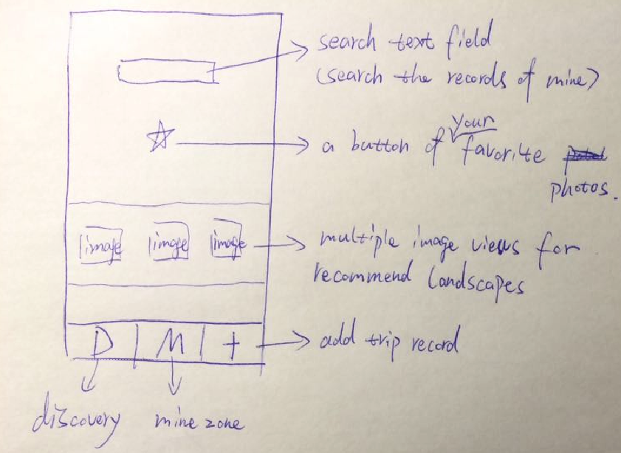

This is the initial page after we launch the APP. At the top, it’s basically a text field for searching feature. It supports user to search their own records. (Photos base on trip destination) And the lower button is a favorite functionality, user can access their favorite photos via this button. More lower is consisted of multiple image views for landscapes which are recommended by us. (I’m still not sure how to fulfill this feature right now, both statically input or dynamically loading through network are possible) At the bottom, it’s a tab bar which consists of three tabs. We are going through D tab right now. Basically D page could search, view favorites and recommendation destination.

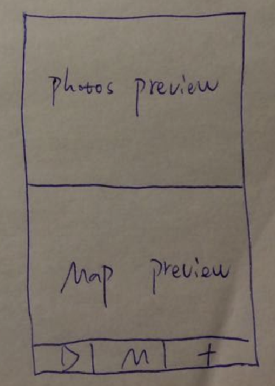

Left is the page that M tab can get you. The top half is photos preview, user could swipe and look through all the photos in their records. And the full image will show up if user click on it. Moreover, I’m going to add a timer on it, let all photos roll automatically. At the bottom half, it’s a map preview. (I might use a static map screenshot of all the places that user already been, or just a simply image) There would be a table view lists all the records after user click on the map preview. Just Like the below image:

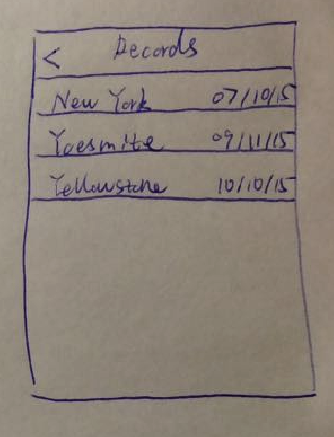

When user click on one of those records, we will bring them a map view show all the places where they have been in this one trip.

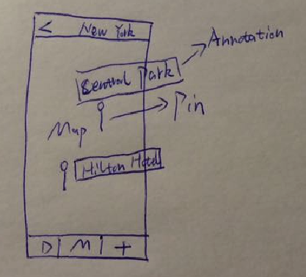

One pin per place, and user could click on the annotation above the pin, which leads to all photos and comments about this place. The basic interface should be like the following image:

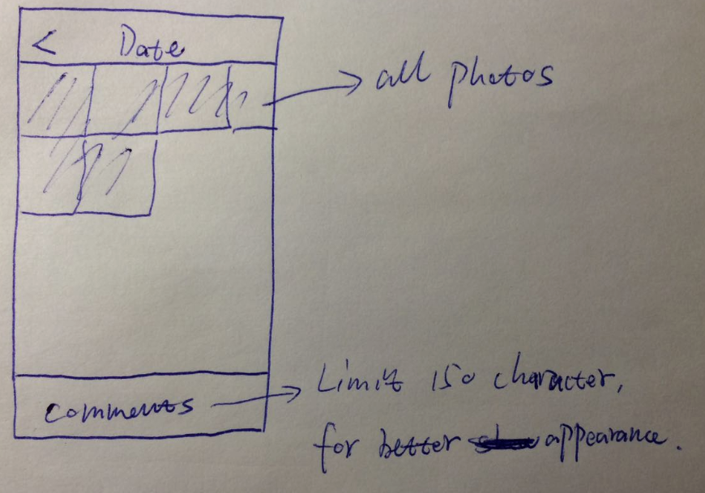

All we have mentioned above, it’s kind of display functionally. Now let’s take a look at the add tab, user is going to see the below interface when they tap +.

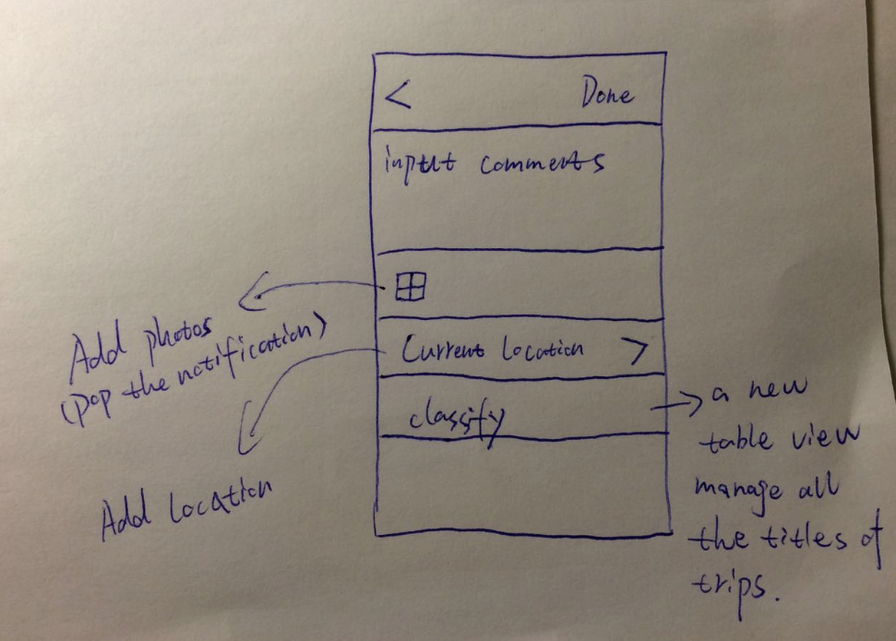

As we can see, the most top is the navigation bar, and then is the comments field. At the middle of this page, user could add photos through the plus button. And it would pop a notification which provide you two options, use existence or take new photo. Then is a location detection, user could input the address or use the current location. The lowest cell is classify, user is going to decide which trip they want to add photos and comments.

Actually this is only our preconceived opinions about what our application going to be, but there are other modules we still thinking about to replace or add in our application, just like multiple users, map routing for all trips and many others.